CODE IMPLEMENTATION – DEAKIN ENERGY

1. Install Python 3.6.x
2. Check if Environment variable is set to python directory
3. Open Command Prompt

Implement following Steps to install flask (<https://www.tutorialspoint.com/flask/flask_environment.htm> )

**python -m pip install virtualenv ( Create a virtual environment)**

**mkdir newproj ( Create new directory ‘new proj’)**

**cd newproj**

**python -m virtualenv venv ( Check ‘venv’ folder in generated in ‘new proj’ file)**

**venv\scripts\activate**

**python -m pip install flask**

1. Extract files and paste it in the “newproj” file.



1. Install libraries in command prompt

**python -m pip install pandas**

**python -m pip install matplotlib**

**python -m pip install tensorflow==1.13**

**python -m pip install sklearn**

**python -m pip install keras**

1. Create a folder named “Uploads” in Local Disk D
2. Create a folder named “Data” in “newproj” file.
3. Run the project code

**python main.py**

If there are any errors popping up in your computer, please try to solve it accordingly!

1. You can find the following URL while its running,

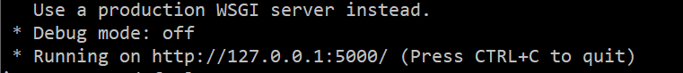

Copy the URL and paste it in your browser.

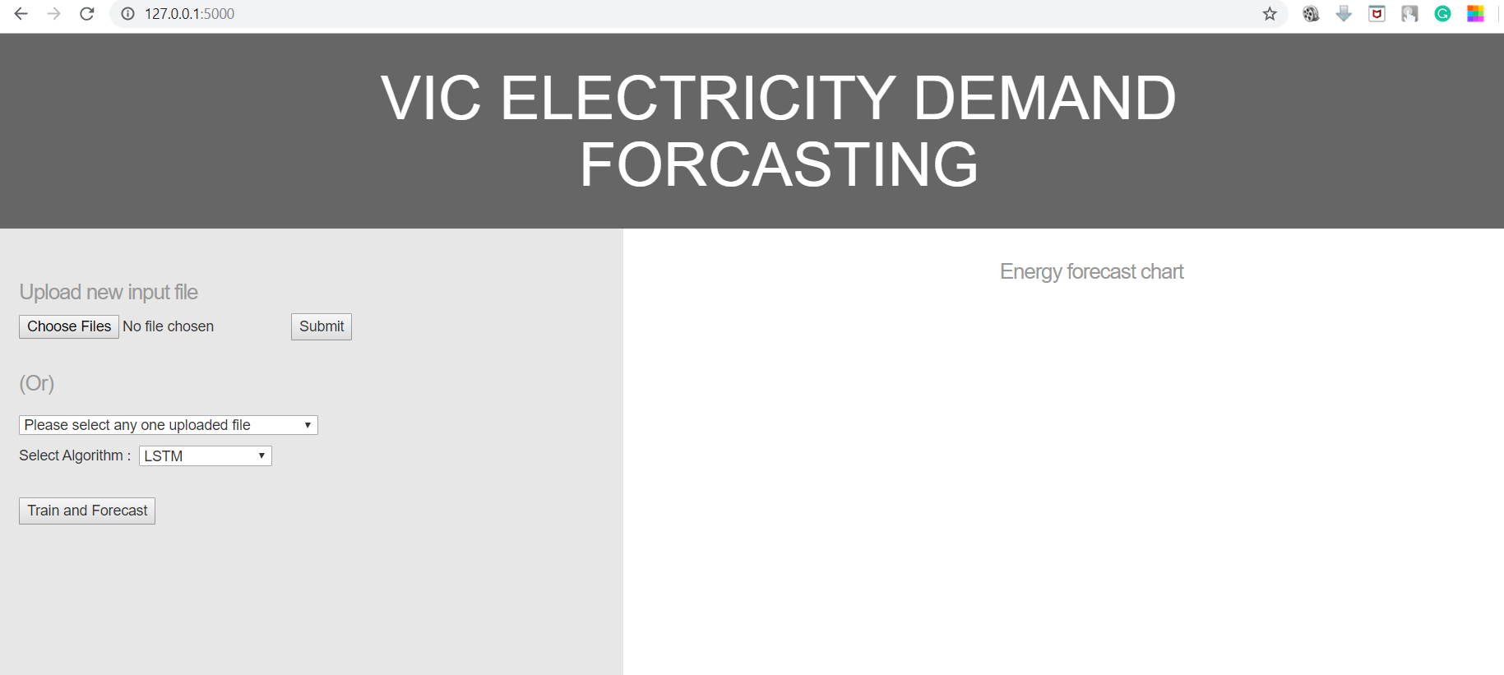

1. Upload the following CSV file downloaded from AEMO website. For example, I have chosen 2019 March month data for Victoria state. You can download and try for any month or any state.



1. Select Algorithm which you want to perform and click ‘Train and Forecast’. Prediction graph and RMSE value will be displayed.

